A

Technical Report

on

**GAS LEAKAGE DETECTOR**

*Submitted to CMR Institute of Technology in the partial fulfillment of the requirement of*

**Social Innovation Lab**

Of

**II B.Tech I- Semester**

in

**ECE DEPARTMENT**

Submitted by

**JILLA.SOWJANYA (20R01A0426)**

***Under the esteemed guidance of***

*Mrs.K.Neelima*

*Assistant Professor*



**CMR INSTITUTE OF TECHNOLOGY**

**(UGC-AUTONOMOUS)**

(Approved by AICTE, Permanently Affiliated to JNTU Hyderabad, Accredited by NBA, Accredited by NAAC with A Grade)

Kandlakoya (V), Medchal Road, Hyderabad  501 401

**2021-2022**

***Department of ECE***

**Certificate**

This is to certify that the technical report entitled“***GAS LEAKAGE DETECTOR***” is the bonafide work done and submitted by

**JILLA.SOWJANYA (20R01A0426)**

towards the partial fulfillment of the requirement of Social Innovation (SIL) Laboratory of **II B. Tech I-Semester** in **ECE** is a record of bonafide work carried out by them during the period **Aug 2021to Dec 2021.**

**Guide Co- Ordinator Head of Department**

***Mrs.K.Neelima Mr.P.Nagaraja kumar Dr.K.Niranjan reddy***

**INDEX**

**Topics Page No**

**CHAPTER-I INTRODUCTION 1**

**CHAPTER -II Empathize 3**

**CHAPTER -III Define**  **4**

**CHAPTER -IV Ideate 6**

**CHAPTER -V Prototype** 7

**CHAPTER -VI Test 11**

**\*sources and references 12**

1. **INTRODUCTION**

* **WHAT IS SOCIAL INNOVATION?**

The term ‘social innovation ’once rarely heard is ,now often used to describe a whole variety of things that fall into general categories of being both new and good.It’s understandable that the phrase has become popular-we get excited and hopeful when it seems possible for real change to happen in the world.

Social innovation refers to the Design and implementation of new solutions that imply conceptual ,process ,product or organisational change which ultimately aim to improve the welfare and wellbeing of individual communities

Social innovation is not a new concept and should not be considered similar to other definitions, such as social entrepreneurship, creativity or invention, improvement or change. 'As with innovation in technology or business, social innovation is distinct from ‘improvement’ or ‘change’ and from ‘creativity’ and ‘invention’. These last two are both crucial to innovation but overlook the important stages of implementation and diffusion which make new ideas useful.

* **What is design thinking process?**

Design Thinking is a design methodology that provides a solution-based approach to solving problems. It’s extremely useful in tackling complex problems that are ill-defined or unknown, by understanding the human needs involved, by re-framing the problem in human-centric ways, by creating many ideas in brainstorming sessions, and by adopting a hands-on approach in prototyping and testing. Understanding these five stages of Design Thinking will empower anyone to apply the Design Thinking methods in order to solve complex problems that occur around us — in our companies, in our countries, and even on the scale of our planet.

Design thinking originally came about as a way of teaching engineers how to approach problems creatively, like designers do. One of the first people to write about design thinking was John E. Arnold, professor of mechanical engineering at Stanford University.

**1**

**The five stages of design thinking:**

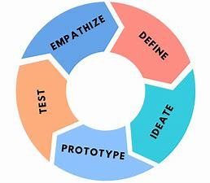

1. Empathize-The Design Thinking process starts with empathy. In order to create desirable products and services, you need to understand who your users are and what they need.
2. Define- In the second stage of the Design Thinking process, you’ll define the user problem that you want to solve.
3. Ideate.-The third stage in the Design Thinking process consists of ideation or generating ideas. ...
4. Prototype- In the fourth stage of the Design Thinking process, you’ll turn your ideas from stage three into prototypes.
5. Test -The fifth step in the Design Thinking process is dedicated to testing: putting your prototypes in front of real users and seeing how they get on.

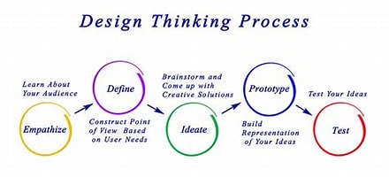  **2**

1. **Empathize**

The first stage of the Design Thinking process is to gain an empathic understanding of the problem you are trying to solve. This involves consulting experts to find out more about the area of concern through observing, engaging and empathizing with people to understand their experiences and motivations, as well as immersing yourself in the physical environment so you can gain a deeper personal understanding of the issues

involved. Empathy is crucial to a human-centered design process such as Design Thinking, and empathy allows design thinkers to set aside their own assumptions about the world in order to gain insight into users and their needs.

We have collected information from various sources like conducting surveys among the people about their problems as they are facing right now and interviewing people, reading novels from various books ,collecting information from the internet.

As our team has conducted a survey among the people at the current problems they are facing we have got many problems to be listed .In those information we have found many valid problems as they are facing in the day to day life and the collected information have been segregated accordingly.

We have shortlisted few problems which are being affected by the most people in the society .



So , have chosen one of the problem that is the gas leakage is the major problem from the shortlisted problems that many people are facing and its causes wealth lose , human lose and many more .

**3**

**3.Define**

In this define stage, we have defined the problem statement accordingly to our problem. According to the scenario as we have collected information in the empathy stage we have defined the problem statement as “Gas leakage at homes” we have come to this conclusion because as per the survey we have conducted, people stated that this a major problem that should be considered it might look simple but as you can see gas leaking will be dangerous and it we don’t take it for serious it might take our lives away and also it’s a slow poison because if are in contact frequently with the gas it might displace air in lungs and causes breathing problems and many more and many disasters happened few years ago as u can look into the previous years news.

So ,we have considered this is the problem statement as per our thesis that we have done. This also targets the major market in the society. The leakage of the gas can be from anywhere from the stove to the cylinder so we have to consider this point mainly.In many areas we have have seen the trouble that been done by the leakage of gas cylinders and children lifes gone to danger and family collapsed more wealth lose etc .

It may also damage your heart by causing irregular heart beat and high blood pressure .It may also reduce blood cells ,damage lungs and cause liver and kidney inflammation. Explosion from LPG can result in serious burns and can cause multiple injuries and even death.

Not only this by frequent contact with gas causes many breathing problems and harms children below 3 years too.. so we should be careful about the gas leakage at our homes. So it is required that we have to concentrate on the leakage activity happened during gas leakage process.

**4**

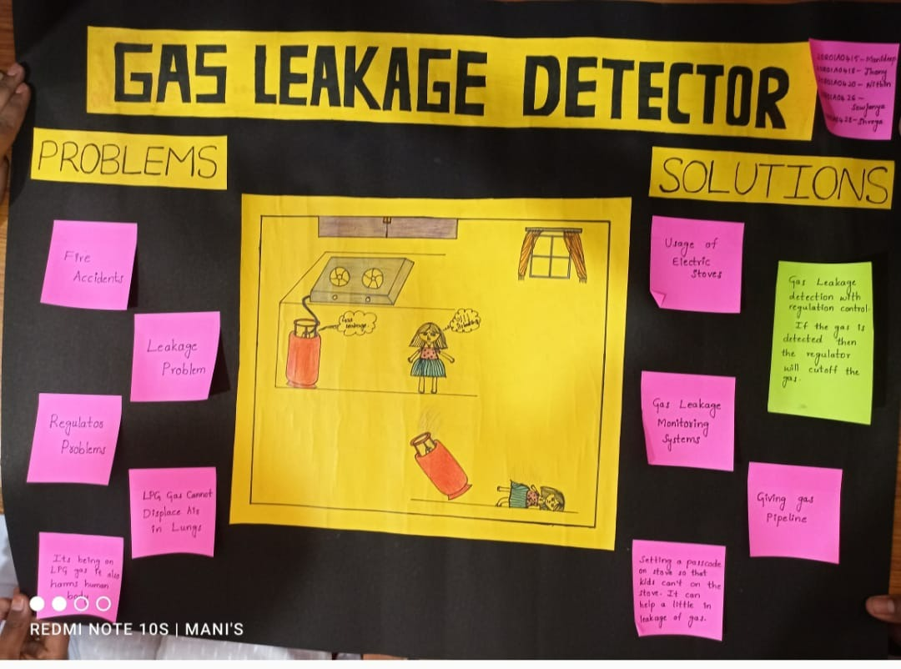

**5**

**4.Ideate**

In this design thinking process we have ideate as the next stage and we have come up with a solution according to the above problem statement as we have mentioned .As we all know gas firstly passes from the regulator and then to the gas pipes then to the stove . from the above scenario as we can assume any type of leakage should passes from the regulator even it can be the stove or pipe if we are able to off the regulator when the gas is leaked then we can control the gas leakage and control the house from danger .

By using Arduino uno we can create a model that sense the lpg gas and it offs the regulator prevent them from danger.so we require some components.so, basically we can create a execution model using the Arduino micro controller which consists of ATmega328P which acts like an interface between the controlling units so using the gas sensor such as mq-6 or any other sensor we can find the gas leakage and using the servo motor we can try to off the regulator so, we should connect them in such a way that if the gas is detected then we should here an alarm and display on a lcd screen that we have high alert message on the lcd and the servo should off the regulator too.

We can use Arduino software for constructing the code and uploading the code to Arduino. There are many versions in the Arduino I suggest use 1.8.16 or 1.8.13 and include libraries if required and execute the code it is easy to learn and it’s a sort of high level language which we can understand easily it is in the form of embedded ‘c’.

**6**

**5.Prototype**

The next step is making a prototype , that is for making a prototype we require components like

Table 1. List of required hardware opponents,

Equipment Quantity Arduino Uno R3 1 MQ-6 LPG gas sensor 1 16*2 LCD 1 Buzzer 1 Male to male/female wire 40 9 V Battery 1 Gas Lighter 1 10 K Variable Resistor 1 Mini Breadboard 1

Servomotor 1

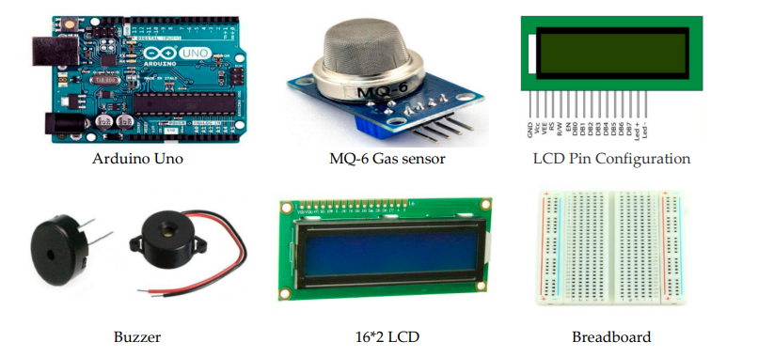

Before starting we will first understand **"What is Gas Sensor ?"**

[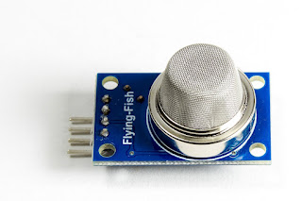](http://3.bp.blogspot.com/-AmDopg5U4Ww/WEBe0pYiDjI/AAAAAAAACps/jqMMf2-9lGsTqOYKt3HcitiQZh4D10towCK4B/s1600/MQ-4-Methangas-Erdgas-Gas-Sensor-Modul-Sensormodul-fur-_57%2B%25281%2529.jpg)[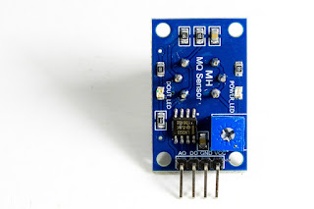](http://3.bp.blogspot.com/-7xWLkCqbmmI/WEBe7nnyE-I/AAAAAAAACp0/VSECSFWQeuEyoQdq8HTSQYfmvR9XXzjYgCK4B/s1600/MQ-4-Methangas-Erdgas-Gas-Sensor-Modul-Sensormodul-fur-_57.jpg)

Gas sensor is a type of sensor which is capable to sense**LPG** gases and can give output HIGH or LOW logic signal to Arduino. **7**

In this project I am using**MQ6 GAS SENSOR**but we can use other also so don't worry.

OK, lets look circuit in bread-board.

[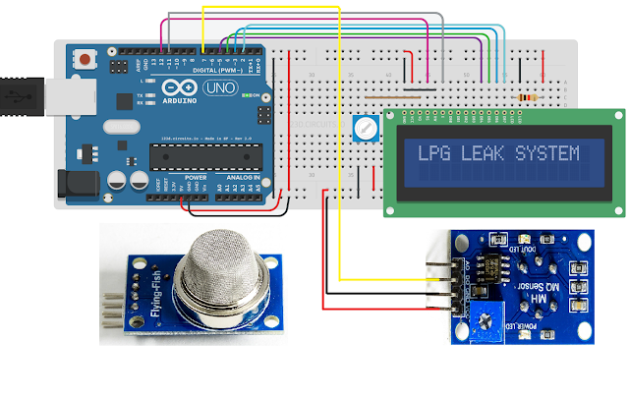](https://4.bp.blogspot.com/-N8Iz5vyNKkc/WEBjgtrMjkI/AAAAAAAACp8/ZCsIHd2Katk23HMNjVz_zEgeARM8fsQUACLcB/s1600/MQ-6%2BGas%2BSensor%2BInterfacing%2Bwith%2BArduino%2BUNO%2Band%2BLCD.png)

By the way you can use pin-13 as output you can connect buzzer or led to alert. I forget to join buzzer in pin-13. Better to put buzzer.

Now connect the servomotor give its connections..

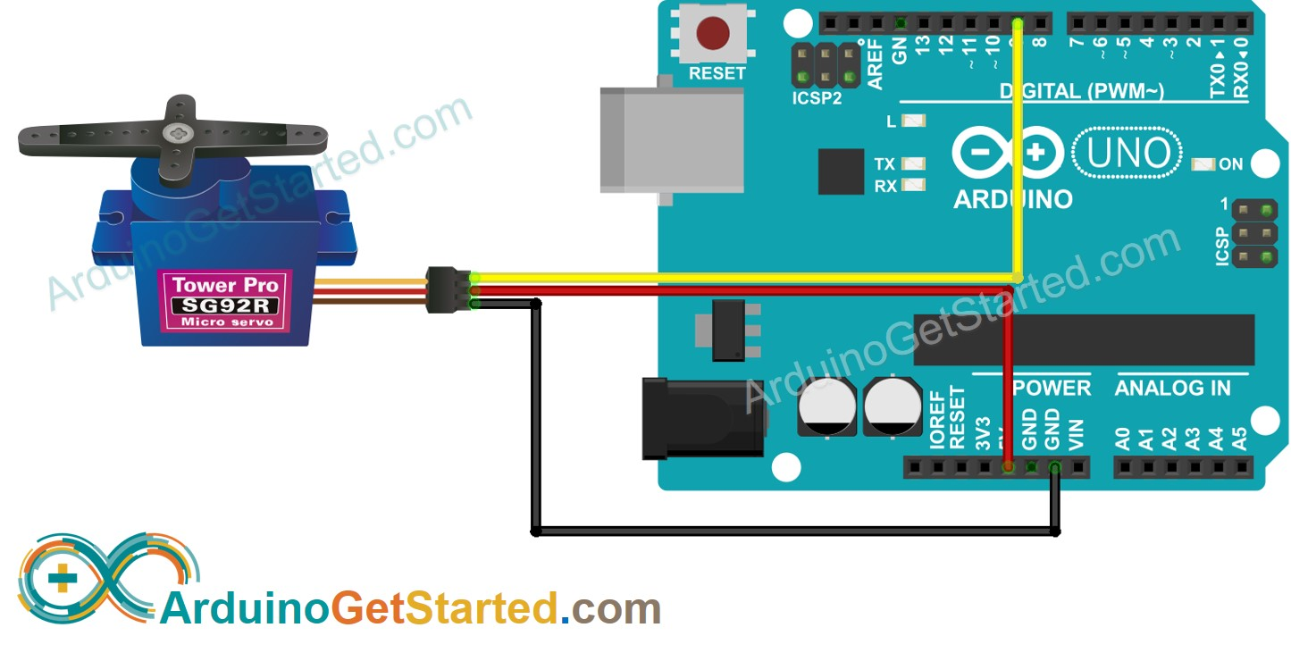

**8**

**Source code:**

#include <LiquidCrystal.h>

#include <Servo.h>

Servo myservo;

LiquidCrystal lcd(12, 11, 5, 4, 3, 2);

int pos = 0;

int led = 13;

int GAS_DO = 6;

int STATE = 0;

void setup() {

myservo.attach(9);

lcd.begin(20,2);

lcd.print("LPG LEAK SYSTEM");

delay(1500);

lcd.clear();

pinMode(led, OUTPUT);

pinMode(GAS_DO, INPUT);

}

void loop() {

STATE = digitalRead(GAS_DO);

if (STATE == LOW) {

digitalWrite(led,LOW);

lcd.print("SAFE");

lcd.setCursor(0,1);

lcd.print("NO LPG LEAKAGE");

delay(125);

lcd.clear();

myservo.write(0);

} else {

digitalWrite(led, HIGH);

lcd.print("HIGH ALERT");

lcd.setCursor(0,1);

lcd.print("GAS IS LEAKED");

delay(250);

lcd.clear();

delay(100);

myservo.write(180);

}

}

Upload this code in Arduino using Arduino software

9

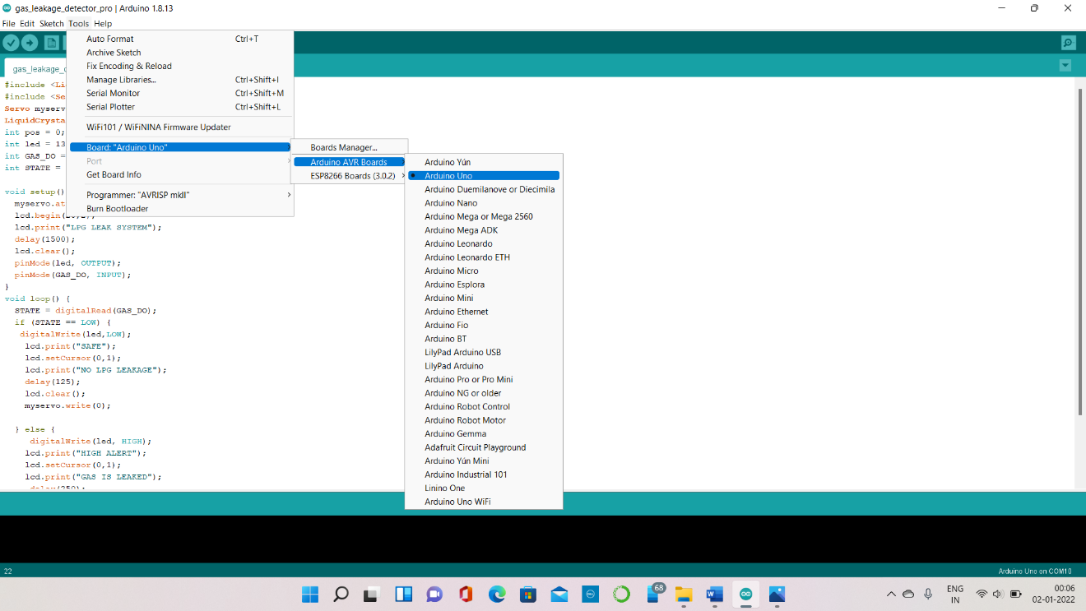

Select the board and port

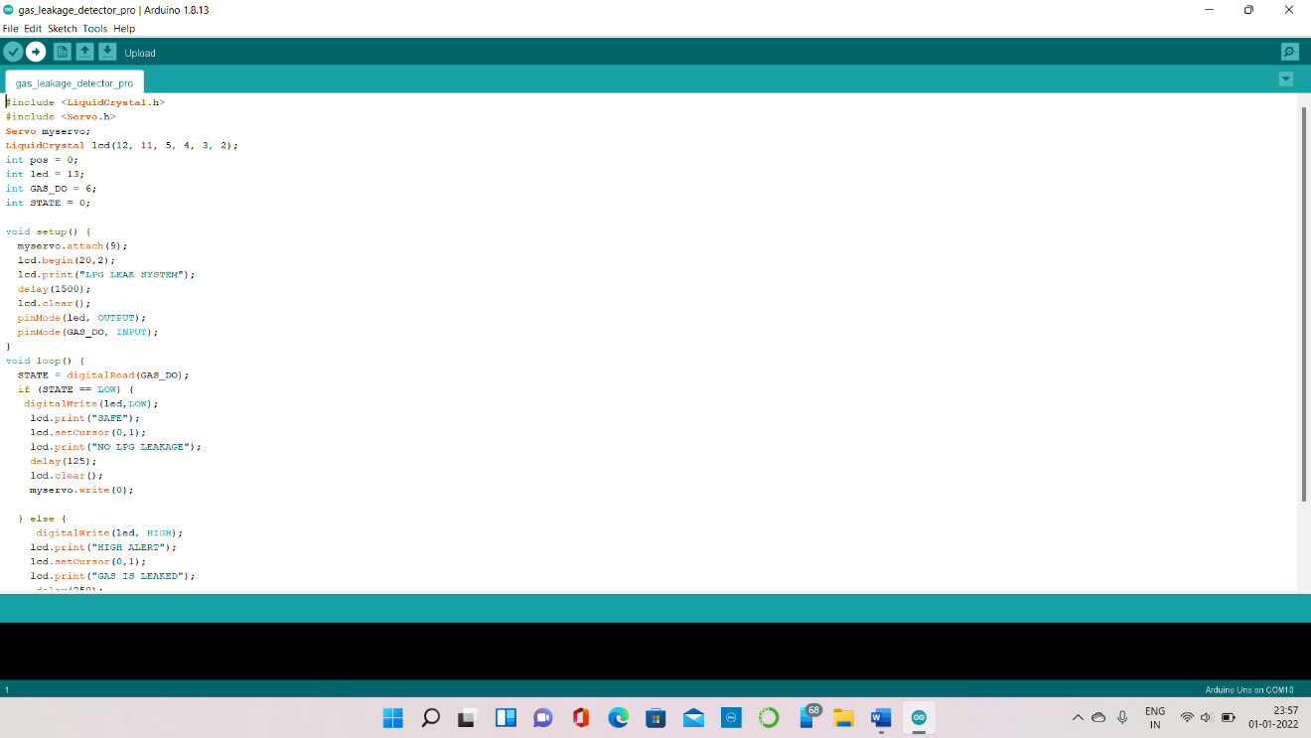

Compile the code and run the code…

10

6.**Test**

We have tested the gas leakage detector many times as per the convience and the usage and we have changed the working models as per the requirement and made a final model

And code that works more efficiently than anyother we have debug the few errors and we have sloved the buzzer problem which is frequently buzzing and made the servo to move and off the regulator.

In the every test case I have found many errors ,and bugs that interrupt the lcd screen and some times the lcd screen speak gibberish which is unable to understand .so using the web sources I have found many solutions which made me easy to slove and debug the things which made us trouble .

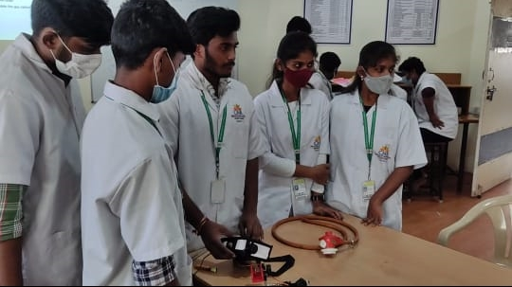

And the thing here is that the connections should be very appropriate if fails to put the connections properly he cant go further in the project every connection has its own function. And also check the connections thrice whether the vcc is and ground is properly fixed or not . coming to the signal pins or pulse width modulation pins and analog pins we are used to connect according to the code that we have given to the Arduino other wise the code doesn’t work .

Testing the setup ‘n’ number of times will make us to clear all the loop holes which are in it . And the final product efficient and its performance is be good and considerable and other working models.

And while uploading the code make sure you are connected to the port and upload it using the rightarrow.

**11**

**SOURCES AND REFERNCES :**

[Engineering Proceedings | Free Full-Text | Sensor-Based Gas Leakage Detector System (mdpi.com)](https://www.mdpi.com/2673-4591/2/1/28)

engproc-02-00028.pdf

[Arduino - Servo Motor | Arduino Tutorial (arduinogetstarted.com)](https://arduinogetstarted.com/tutorials/arduino-servo-motor)

[MQ-6 Gas Sensor Interfacing with Arduino UNO and LCD (allaboveelectronics.blogspot.com)](http://allaboveelectronics.blogspot.com/2016/12/mq-6-gas-sensor-interfacing-with.html)

12